The purpose of the analysis is to explain how my data is preprocessed and the process I used to compile, train and evaluate the model.

During data processing IS_successful are the targets in the model. I removed EIN and Names from the input data because they are neither target nor features

To achieve the best results, I first used 2 layers then 3 and 4 layers.

Using 2 layers,

My accuracy is 72%

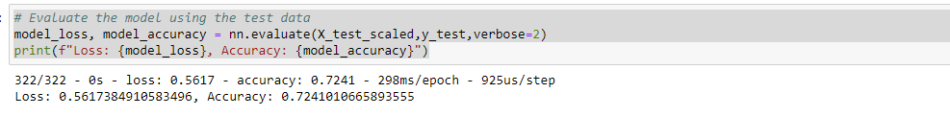

the Roc Curve is 77%

I then added another layer

My accuracy is 72%

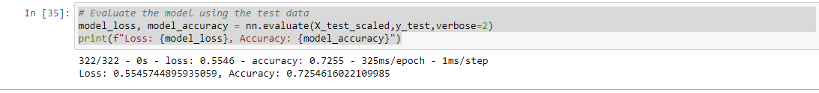

The ROC Curve increased to 78%

I added a 4th layer

My accuracy is 72%



My ROC Curve is 78%

